# **What are Google Negative Reviews?**

Welcome to our blog post, where we delve into the intriguing world of Google Negative Reviews! In today's digital age, online reviews have become a powerful tool that can make or break a business. While positive reviews are highly sought after, negative ones often get a bad rap. But what if we told you that [**negative Google Reviews could actually**](https://usukshop.com/product/buy-negative-google-reviews/) be advantageous? Yes, you heard it right! In this article, we will explore the hidden benefits of negative reviews and even dive into the controversial topic of buying them legally. So buckle up and join us on this exciting journey as we uncover the surprising ways in which negative Google Reviews can impact your business positively. Let's get started!

## **Our Service Always Trusted Customers sufficient Guarantee-**

When it comes to our service, we pride ourselves on providing a trusted and reliable experience for our customers. We understand that trust is essential in any business relationship, which is why we go above and beyond to ensure customer satisfaction.  
  
One of the ways we demonstrate this commitment is through our sufficient Guarantee. We want our customers to feel confident in their decision to choose us, which is why we stand by the quality of our service. If you have any concerns or issues, rest assured that we will address them promptly and find a satisfactory resolution.  
  
We believe that transparency is key when it comes to building trust with our customers. That's why we strive to provide clear communication throughout the entire process. From the moment you engage with us until after your transaction is complete, you can count on us to keep you informed every step of the way.  
  
Our dedication extends beyond just meeting expectations – we aim to exceed them. By consistently delivering exceptional service and going above and beyond for our customers, we hope to build long-lasting relationships based on trust and reliability.  
  
So, if you're looking for a service provider who values your satisfaction as much as you do, look no further! Trust in us as countless others have done before, and let us show you firsthand what sets us apart from the competition.

## **What Advantages of Negative Google Reviews?**

What advantages do negative Google reviews bring? While most businesses strive to maintain a positive online reputation, there are actually some benefits to having a few negative thoughts.   
  
Negative reviews can provide valuable feedback and insights into areas of improvement for your business. They shed light on specific issues that need attention and allow you to address them promptly. By addressing these concerns, you show potential customers that you value their feedback and are committed to providing excellent service.  
  
Negative reviews can add credibility to your overall review profile. When potential customers see a mix of positive and negative reviews, it appears more authentic and trustworthy than an overwhelming number of perfect ratings. It shows that your business is genuine and transparent.  
  
Negative reviews can help you differentiate yourself from competitors who may have only positive reviews. Customers often compare businesses before making a decision, so seeing how well you handle criticism sets you apart as responsive and customer-oriented.  
  
However, it's important not to focus solely on negative reviews or deliberately seek them out. Maintaining an overall positive reputation should still be the goal – but don't discount the value that constructive criticism can bring in helping your business grow.

## **Can you legally buy Google reviews?**

[**Can you legally buy Google reviews**](https://usukshop.com/product/buy-negative-google-reviews/)? This is a question that many businesses may ask themselves when striving to improve their online reputation. While it may be tempting to take shortcuts and purchase positive reviews, it is important to consider the ethical and legal implications of such actions.  
  
Buying Google reviews goes against Google's review policy, which states that "posting fake content, including fake reviews" is strictly prohibited. Engaging in these practices can result in severe consequences for your business, including the removal of your listing from Google or even legal action.  
  
Furthermore, purchasing reviews undermines the trust and integrity of online review systems. Authenticity and transparency are crucial in maintaining a fair marketplace where consumers can make informed decisions based on genuine feedback from real customers.  
  
Instead of resorting to unethical practices like buying reviews, focus on building an excellent customer experience that naturally generates positive feedback. Encourage satisfied customers to leave honest reviews and respond promptly and professionally to any negative feedback received.  
  
Remember, fostering trust with your audience should always be a top priority. It may take time and effort, but building a solid reputation through legitimate means will benefit your business in the long run.

## **Negative Google Reviews Can Assist You With Beating Different Contenders?**

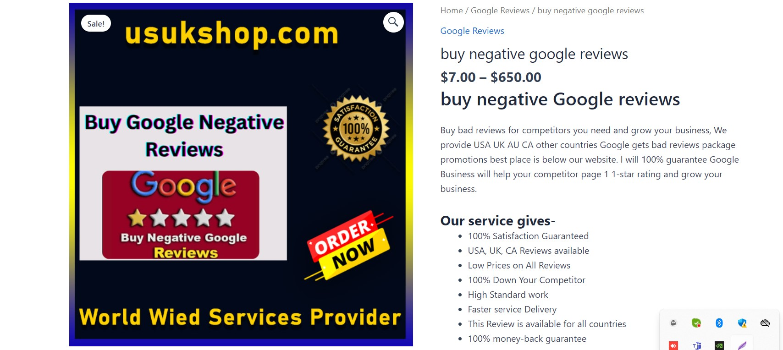

Negative Google reviews can actually work in your favor when it comes to beating your competitors. While positive reviews are undoubtedly important for building trust and credibility, negative reviews can be seen as an opportunity to showcase how you handle customer feedback and improve your business.  
  
When potential customers see negative reviews of your competitors, it gives them a chance to compare the quality of service or product between different businesses. If you have a higher average rating despite a few negative reviews, it sets you apart from your competition.  
  
Furthermore, negative reviews provide valuable insights into areas where you may need improvement. By actively addressing these concerns and making necessary changes, you demonstrate that you value customer satisfaction and are committed to providing the best possible experience.  
  
Remember that no business is perfect; everyone will receive some negative feedback at some point. The key is in how you respond. Responding professionally and constructively shows potential customers that their opinions matter to you and that they can expect excellent customer service if they choose to do business with you.  
  
So, next time someone leaves a negative review on Google, don't panic! Use it as an opportunity to learn and grow. Showcasing how well you handle criticism can help set yourself apart from the competition in a positive light.

## **Impressed by our experience in making you buy negative Google reviews**

Impressed by our expertise to make you purchase negative Google reviews  
  
At Our Service Always Trusted Customers Sufficient Guarantee, we understand the importance of online reputation for businesses. We have years of experience in helping companies manage their online presence effectively. One aspect that often gets overlooked is the power of negative Google reviews.  
  
While positive reviews are essential for building trust and credibility, negative reviews can also serve a purpose. They provide valuable feedback and highlight areas where improvements can be made. By addressing these concerns promptly and professionally, businesses can demonstrate their commitment to customer satisfaction.  
  
But how do you go [**about buying negative Google reviews**](https://usukshop.com/product/buy-negative-google-reviews/)? Is it even legal? The truth is that purchasing any type of review violates Google's policies and could result in severe consequences, such as account suspension or removal from search results. It's simply not worth the risk.  
  
Instead, focus on providing exceptional products or services that will naturally generate positive feedback from your customers. Please encourage them to leave honest reviews based on their experiences with your business.  
  
Remember, beating your competitors isn't just about having more positive reviews; it's about delivering an outstanding customer experience that speaks for itself. Trust in your abilities and strive to create genuine connections with your target audience – this will ultimately lead to greater success in the long run.  
  
At Our Service Always [**Trusted Customers Sufficient Guarantee,**](https://usukshop.com/product/buy-remove-negative-reviews/) we believe in ethical practices when it comes to managing online reputations. Instead of resorting to tactics like buying fake negative reviews, let us help you build a solid foundation through organic growth strategies tailored specifically to your business needs.  
  
Contact us today and let our team of experts guide you toward achieving a stellar online reputation without compromising integrity!

## **How do I buy negative Google reviews? Read the policy carefully**

When it comes to buying negative Google reviews, it is crucial to tread carefully and understand the policies in place. Before engaging in such practices, it is important to read and comprehend the procedure regarding online reviews set by Google.  
  
The first step is to familiarize yourself with the guidelines provided by Google on review content. These guidelines outline what constitutes a violation and what actions can be taken against accounts that engage in fraudulent activities. It's essential to ensure that you fully understand these rules before proceeding.  
  
Next, consider the potential consequences of [**purchasing negative reviews**](https://usukshop.com/product/buy-remove-negative-reviews/). While they may seem like a quick solution for beating competitors, there are risks involved. Buying fake reviews not only goes against ethical standards but also violates Google's terms of service.  
  
Furthermore, attempting to manipulate your online reputation through deceitful means can lead to severe penalties from search engines or even legal action from disgruntled customers or competitors who uncover your tactics.  
  
While buying negative Google reviews might appear enticing at first glance, it's important to remember that such actions come with significant risks and consequences. It is always advised to focus on providing excellent products or services instead of resorting to unethical practices.